Synthesis of a Current Issue: FOLLOWING A COLUMNIST
AP English Language

Some of the most prominent practitioners of stylish written rhetoric in our culture are newspaper columnists. Sometimes they are called pundits – that is, sources of opinion, or critics.

On the reverse side find a list of well-known newspaper columnists. Select one (or another one that I approve of) and complete the tasks below. Please start a new page and label as TASK # each time you start a new task.

TASK 1—Brief Biography.
Write a brief (100-200 word) biography of the columnist. Make sure you cite your source(s) at the bottom of the page. I suggest you import a picture of the author if possible.

TASK 2—Five Annotated Columns.
Make copies from newspapers or magazines or download them from the internet. I suggest cutting and pasting the columns into Microsoft word and double-spacing them because it makes them easier to annotate and work with. Your annotations should emphasize such things as:
- the central idea of the column
- identify appeals to logos, pathos, or ethos
- (by what means does the columnist seek to convince readers of the truth of his central idea?)
- the chief rhetorical and stylistic devices at work in the column
- the tone (or tones) of the column
- errors of logic (if any) that appear in the column
- the way the author uses sources, the type of sources the author uses (Be sure to pay attention to this one!)
- the apparent audience the author is writing for
Add a few final comments to each column that summarizes your general response to the piece—
do not summarize the column! This task is hand-written.

TASK 3 – Depth Analysis of One Column and Two Extras.
Choose a favorite column from Task 2 and compare it to two other treatments of the same
subject:
- a straight, un-slanted news report about the topic of the column or
- another columnist’s opposing take on the issue or
- an editorial or
- a letter to the editor that disagrees with the original column.
Informed by the two extras you found and your own thinking and reading on the subject, write a
brief assessment of the original column. Is it sound? Is it convincing?

TASK 4 – Final Remarks
Add a statement titled ―Final Remarks.‖ In this reflect on what your learned, what value this
had, what you think of the writer or subject matter, etc.

PROMINENT NEWSPAPER COLUMNISTS

Michael Kinsley –founder of slate.com. Syndicated columnist. L
http://www.washingtonpost.com/wp-dyn/content/opinions/
Richard Cohen – Washington Post columnist. l http://www.washingtonpost.com/wp-dyn/content/opinions/
Bob Herbert – New York Times columnist. L
http://www.nytimes.com/pages/opinion/index.html
William F. Buckley – founder of National Review. Syndicated columnist C
http://www.nationalreview.com/buckley/buckley.asp
Thomas Sowell – Hoover Institute scholar. Syndicated columnist C
http://www.townhall.com/columnists/thomassowell/archive.shtml
Ellen Goodman - Boston Globe columnist. L
http://www.boston.com/news/globe/editorial_opinion/oped/goodman/
George Will – Washington Post columnist. C
http://www.washingtonpost.com/wp-dyn/content/opinions/ John Tierney – New York Times columnist. c
http://www.nytimes.com/pages/opinion/index.html
David Brooks - New York Times columnist. c http://www.nytimes.com/pages/opinion/index.html
Paul Krugman - New York Times columnist. L
http://www.nytimes.com/pages/opinion/index.html
Thomas Friedman - New York Times columnist. l http://www.nytimes.com/pages/opinion/index.html
Jonah Goldberg - Los Angeles Times columnist. c http://www.latimes.com/news/columnist
Peggy Noonan - former presidential speechwriter; Wall Street Journal columnist. C
http://www.opinionjournal.com/columnists/pnoonan/
Maureen Dowd - ―Modo‖ New York Times columnist. L
http://www.nytimes.com/pages/opinion/index.html
Charles Krauthammer - Washington Post columnist. c
http://www.washingtonpost.com/wp-dyn/content/opinions/ Mona Charen - syndicated columnist. C
http://www.townhall.com/columnists/monacharen/archive.shtml
E.J. Dionne - Washington Post columnist. l
http://www.washingtonpost.com/wp-dyn/content/opinions/ Cynthia Tucker – Atlanta Journal-Constitution columnist. L
http://www.ajc.com/opinion/content/opinion/tucker/index.html

Pictured below:
top row: Will, Charen, Dionne, Tucker, Tierney, Krauthammer, Kinsley, Cohen, Herbert
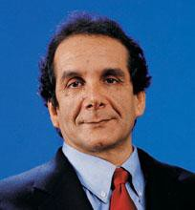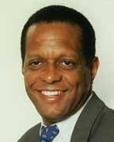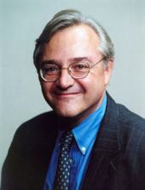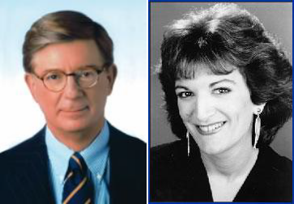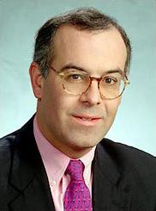bottom row: Buckley, Sowell, Goodman, Brooks, Krugman, Friedman, Goldberg, Noonan, Dowd

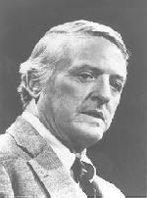e o 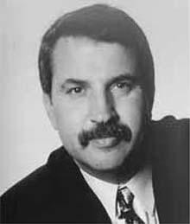

of Jim Veal Ridge High Sch GA

ol

Courtesy Peachtre Suwanee
,

